**Домашнее задание №7**

**по дисциплине:**

«Дискретная математика»

*Вариант 28*

*A = 9,7; B = 0,073*

**Формат Ф1** (число разрядов мантиссы m = 12, ускоренное умножение по 2 разряда):

A = (9,7)10 = (9,B333...)16 ≈ (0,9B3)16 * 161

XA = (1 + 64)10 = (65)10 = (1000001)2

|  |  |  |  |
| --- | --- | --- | --- |
| 0 | 1000001 | 100110110011 | |
| *0* | *1 7* | | *8 19* |

B = (0,073)10 = (0,12B02...)16 ≈ (0,12B)16 * 160

XB = (0 + 64)10 = (64)10 = (1000000)2

|  |  |  |  |
| --- | --- | --- | --- |
| 0 | 1000000 | 000100101011 | |
| *0* | *1 7* | | *8 19* |

SignC = SingA ⊕ SingB = 0 ⊕ 0 = 0

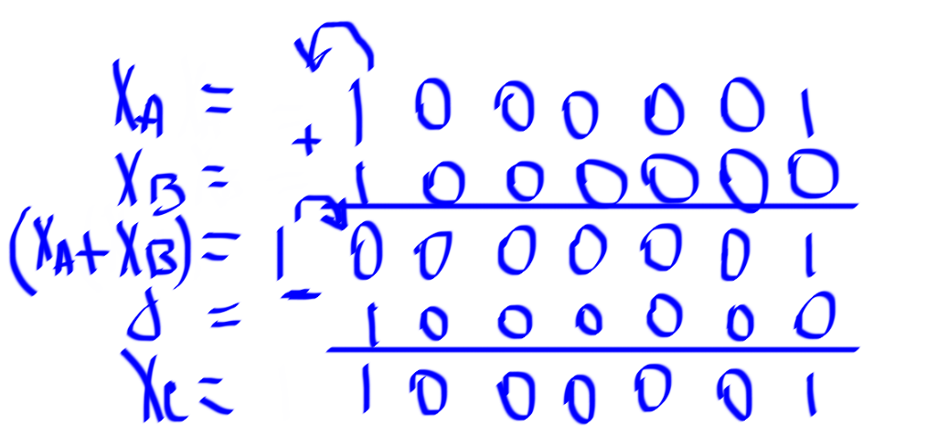

|  |  |  |  |  |  |  |  |  |  |  |  |  |  |  |  |  |  |  |  |  |  |  |  |  |  |  |  |  |  |
| --- | --- | --- | --- | --- | --- | --- | --- | --- | --- | --- | --- | --- | --- | --- | --- | --- | --- | --- | --- | --- | --- | --- | --- | --- | --- | --- | --- | --- | --- |
| **№** | **Операнды** | **СЧП (старшие разряды)** | | | | | | | | | | | | | | | **В/СЧП (младшие**  **разряды)** | | | | | | | | | | | | **Признак коррекции** |
| **0** | СЧП | 0 | 0 | 0 | 0 | 0 | 0 | 0 | 0 | 0 | 0 | 0 | 0 | 0 | 0 | 0 | 0 | 0 | 0 | 1 | 0 | 0 | 1 | 0 | 1 | 0 | **1** | **1** | 0 |
| **1** | –MA | 1 | 1 | 1 | 0 | 1 | 1 | 0 | 0 | 1 | 0 | 0 | 1 | 1 | 0 | 1 | –MA | | | | | | | | | | | | 1 |
| СЧП - MA | 1 | 1 | 1 | 0 | 1 | 1 | 0 | 0 | 1 | 0 | 0 | 1 | 1 | 0 | 1 | 0 | 0 | 0 | 1 | 0 | 0 | 1 | 0 | 1 | 0 | 1 | 1 |
| СЧП –> 2 | 1 | 1 | 1 | 1 | 1 | 0 | 1 | 1 | 0 | 0 | 1 | 0 | 0 | 1 | 1 | 0 | 1 | 0 | 0 | 0 | 1 | 0 | 0 | 1 | 0 | **1** | **0** |
| **2** | –MA | 1 | 1 | 1 | 0 | 1 | 1 | 0 | 0 | 1 | 0 | 0 | 1 | 1 | 0 | 1 | –MA | | | | | | | | | | | | 1 |
| СЧП - MA | 1 | 1 | 1 | 0 | 0 | 1 | 1 | 1 | 1 | 1 | 0 | 0 | 0 | 0 | 0 | 0 | 1 | 0 | 0 | 0 | 1 | 0 | 0 | 1 | 0 | 1 | 0 |
| СЧП –> 2 | 1 | 1 | 1 | 1 | 1 | 0 | 0 | 1 | 1 | 1 | 1 | 1 | 0 | 0 | 0 | 0 | 0 | 0 | 1 | 0 | 0 | 0 | 1 | 0 | 0 | **1** | **0** |
| **3** | –MA | 1 | 1 | 1 | 0 | 1 | 1 | 0 | 0 | 1 | 0 | 0 | 1 | 1 | 0 | 1 | –MA | | | | | | | | | | | | 1 |
| СЧП - MA | 1 | 1 | 1 | 0 | 0 | 1 | 1 | 0 | 1 | 0 | 0 | 0 | 1 | 0 | 1 | 0 | 0 | 0 | 1 | 0 | 0 | 0 | 1 | 0 | 0 | 1 | 0 |
| СЧП –> 2 | 1 | 1 | 1 | 1 | 1 | 0 | 0 | 1 | 1 | 0 | 1 | 0 | 0 | 0 | 1 | 0 | 1 | 0 | 0 | 0 | 1 | 0 | 0 | 0 | 1 | **0** | **0** |
| **4** | +MA | 0 | 0 | 0 | 1 | 0 | 0 | 1 | 1 | 0 | 1 | 1 | 0 | 0 | 1 | 1 | +MA | | | | | | | | | | | | 0 |
| СЧП + MA | 0 | 0 | 0 | 0 | 1 | 1 | 0 | 1 | 0 | 0 | 0 | 0 | 1 | 0 | 0 | 0 | 1 | 0 | 0 | 0 | 1 | 0 | 0 | 0 | 1 | 0 | 0 |
| СЧП –> 2 | 0 | 0 | 0 | 0 | 0 | 0 | 1 | 1 | 0 | 1 | 0 | 0 | 0 | 0 | 1 | 0 | 0 | 0 | 1 | 0 | 0 | 0 | 1 | 0 | 0 | **0** | **1** |
| **5** | +MA | 0 | 0 | 0 | 1 | 0 | 0 | 1 | 1 | 0 | 1 | 1 | 0 | 0 | 1 | 1 | +MA | | | | | | | | | | | | 0 |
| СЧП + MA | 0 | 0 | 0 | 1 | 0 | 1 | 1 | 0 | 1 | 0 | 1 | 0 | 1 | 0 | 0 | 0 | 0 | 0 | 1 | 0 | 0 | 0 | 1 | 0 | 0 | 0 | 1 |
| СЧП –> 2 | 0 | 0 | 0 | 0 | 0 | 1 | 0 | 1 | 1 | 0 | 1 | 0 | 1 | 0 | 1 | 0 | 0 | 0 | 0 | 0 | 1 | 0 | 0 | 0 | 1 | **0** | **0** |
| **6** | 0 | 0 | 0 | 0 | 0 | 0 | 0 | 0 | 0 | 0 | 0 | 0 | 0 | 0 | 0 | 0 | СЧП –> 2 | | | | | | | | | | | | 0 |
| СЧП | 0 | 0 | 0 | 0 | 0 | 1 | 0 | 1 | 1 | 0 | 1 | 0 | 1 | 0 | 1 | 0 | 0 | 0 | 0 | 0 | 1 | 0 | 0 | 0 | 1 | 0 | 0 |
| СЧП –> 2 | 0 | 0 | 0 | 0 | 0 | 0 | 0 | 1 | 0 | 1 | 1 | 0 | 1 | 0 | 1 | 0 | 1 | 0 | 0 | 0 | 0 | 0 | 1 | 0 | 0 | 0 | 1 |
| **7** | 0 | 0 | 0 | 0 | 0 | 0 | 0 | 0 | 0 | 0 | 0 | 0 | 0 | 0 | 0 | 0 | СЧП <– 4 | | | | | | | | | | | |  |
| СЧП | 0 | 0 | 0 | 0 | 0 | 0 | 0 | 1 | 0 | 1 | 1 | 0 | 1 | 0 | 1 | 0 | 1 | 0 | 0 | 0 | 0 | 0 | 1 | 0 | 0 | 0 | 1 |
| MC | 0 | 0 | 0 | 1 | 0 | 1 | 1 | 0 | 1 | 0 | 1 | 0 | 1 | 0 | 0 | 0 | 0 | 0 | 1 | 0 | 0 | 0 | 1 | 0 | 0 | 0 | 0 |

XC = XC – 1

Результат умножения:

|  |  |  |  |
| --- | --- | --- | --- |
| 0 | 100000 | 101101010100 | |
| *0* | *1 7* | | *8 19* |

С* = (0,B54)16 * 160 = (0,B54)16 = (0,7080078125)10

СТ = (9,7 * 0,073)10 = (0,7081)10

ΔС = (0,7080078125 – 0,7081)10 = (0,0000921875)10

δС = · 100% ≈ 0,013%

Погрешности результатов вызваны неточным представлением операндов и потерей младших бит СЧП.

**Формат Ф2** (число разрядов мантиссы m = 11, ускоренное умножение по 4 разряда):

A = (9,7)10 = (1001,10110011001)2 ≈ (0,100110110011)2 * 24

XA = (4 + 128)10 = (132)10 = (10000100)2

|  |  |  |  |
| --- | --- | --- | --- |
| 0 | 10000100 | 00110110011 | |
| *0* | *1 8* | | *9 19* |

B = (0,073)10 = (0,000100101011)2 ≈ (0,100101011)2 * 2-3

XB = (–3 + 128)10 = (125)10 = (10000001)2

|  |  |  |  |
| --- | --- | --- | --- |
| 0 | 01111101 | 00101011000 | |
| *0* | *1 8* | | *9 19* |

SignC = SingA ⊕ SingB = 0 ⊕ 0 = 0

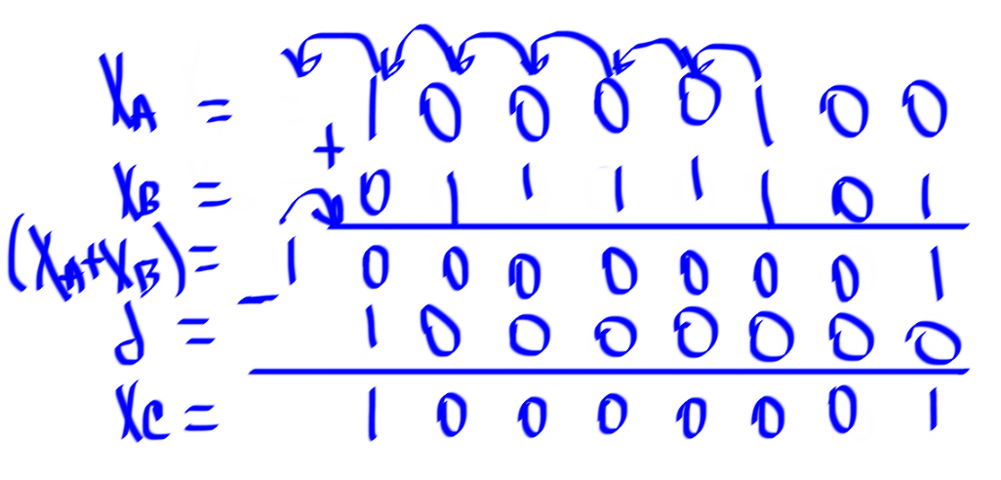

|  |  |  |  |  |  |  |  |  |  |  |  |  |  |  |  |  |  |  |  |  |  |  |  |  |  |  |  |  |  |  |  |  |  |  |  |  |  |  |  |  |  |  |  |  |  |  |  |  |  |  |  |  |  |  |  |  |  |  |  |  |  |
| --- | --- | --- | --- | --- | --- | --- | --- | --- | --- | --- | --- | --- | --- | --- | --- | --- | --- | --- | --- | --- | --- | --- | --- | --- | --- | --- | --- | --- | --- | --- | --- | --- | --- | --- | --- | --- | --- | --- | --- | --- | --- | --- | --- | --- | --- | --- | --- | --- | --- | --- | --- | --- | --- | --- | --- | --- | --- | --- | --- | --- | --- |
| **№** | **Операнды** | **СЧП (старшие разряды)** | | | | | | | | | | | | | | | | | | | | | | | | | | | | | | | | **В/СЧП (младшие**  **разряды)** | | | | | | | | | | | | | | | | | | | | | | | | | **Признак коррекции** | | |
| **0** | СЧП | 0 0 0 0 0 0 0 0 0 0 0 0 0 0 0 0 0 | | | | | | | | | | | | | | | | | | | | | | | | | | | | | | | | 1 0 0 1 0 1 0 1 **1 0 0 0** | | | | | | | | | | | | | | | | | | | | | | | | | **0** | | |
| **1** | +8MA | 0 | 0 | 1 | | 0 | | 0 | | 1 | | 1 | | 0 | | 1 | | 1 | | 0 | | 0 | | 1 | | 1 | | 0 | | 0 | | 0 | | |  | | | | | | | | | | | | | | | | | | | | | | | | | 0 | | | |
| СЧП + 8MA | 0 | 0 | 1 | | 0 | | 0 | | 1 | | 1 | | 0 | | 1 | | 1 | | 0 | | 0 | | 1 | | 1 | | 0 | | 0 | | 0 | | | 1 | | 0 | | 0 | | 1 | | 0 | | 1 | | 0 | | 1 | | 1 0 | | | | 0 0 | | | | |
| СЧП –> 4 | 0 | 0 | 0 | | 0 | | 0 | | 0 | | 1 | | 0 | | 0 | | 1 | | 1 | | 0 | | 1 | | 1 | | 0 | | 0 | | 1 | | | 1 | | 0 | | 0 | | 0 | | 1 | | 0 | | 0 | | 1 | | **0** | | **1** | | **0** | | **1** | | |
| **2** | +4MA | 0 | 0 | 0 | | 1 | | 0 | | 0 | | 1 | | 1 | | 0 | | 1 | | 1 | | 0 | | 0 | | 1 | | 1 | | 0 | | 0 | | |  | |  | |  | |  | |  | |  | |  | |  | |  | |  | |  | |  | | | 0 | | |
| +MA | 0 | 0 | 0 | | 0 | | 0 | | 1 | | 0 | | 0 | | 1 | | 1 | | 0 | | 1 | | 1 | | 0 | | 0 | | 1 | | 1 | | |  | |  | |  | |  | |  | |  | |  | |  | |  | |  | |  | |  | | |
| СЧП + 4MA + MA | 0 | 0 | 0 | | 1 | | 1 | | 0 | | 1 | | 0 | | 1 | | 0 | | 1 | | 0 | | 1 | | 1 | | 0 | | 0 | | 0 | | | 1 | | 0 | | 0 | | 0 | | 1 | | 0 | | 0 | | 1 | | 0 1 | | | | 0 1 | | | | |
| СЧП –> 4 | 0 | 0 | 0 | | 0 | | 0 | | 0 | | 0 | | 1 | | 1 | | 0 | | 1 | | 0 | | 1 | | 0 | | 1 | | 0 | | 1 | | | 1 | | 0 | | 0 | | 0 | | 1 | | 0 | | 0 | | 0 | | **1** | | **0** | | **0** | | **1** | | |
| **3** | +8MA | 0 | 0 | 1 | | 0 | | 0 | | 1 | | 1 | | 0 | | 1 | | 1 | | 0 | | 0 | | 1 | | 1 | | 0 | | 0 | | 0 | | |  | |  | |  | |  | |  | |  | |  | |  | |  | |  | |  | |  | | | 0 | | |
| +MA | 0 | 0 | 0 | | 0 | | 0 | | 1 | | 0 | | 0 | | 1 | | 1 | | 0 | | 1 | | 1 | | 0 | | 0 | | 1 | | 1 | | |  | |  | |  | |  | |  | |  | |  | |  | |  | |  | |  | |  | | |
| СЧП + 8MA + MA | 0 | 0 | 1 | | 0 | | 1 | | 1 | | 0 | | 1 | | 0 | | 1 | | 0 | | 1 | | 0 | | 0 | | 0 | | 0 | | 0 | | | 1 | | 0 | | 0 | | 0 | | 1 | | 0 | | 0 | | 0 | | 1 0 | | | | 0 1 | | | | |
| СЧП –> 4 | 0 | 0 | 0 | | 0 | | 0 | | 0 | | 1 | | 0 | | 1 | | 1 | | 0 | | 1 | | 0 | | 1 | | 0 | | 1 | | 0 | | | 0 | | 0 | | 0 | | 0 | | 1 | | 0 | | 0 | | 0 | | **1** | | **0** | | **0** | | **0** | | |
| **4** |  | | | | | | | | | | | | | | | | | | | | | | | | | | | | | | | | | | | | | | | | | | | | | | | | | | | | | | | | | | | | |
| СЧП <– 1 | 0 | 0 | | 0 | | 0 | | 0 | | 1 | | 0 | | 1 | | 1 | | 0 | | 1 | | 0 | | 1 | | 0 | | 1 | | 0 | | 0 | | | 0 | | 0 | | 0 | | 1 | | 0 | | 0 | | 0 | | 1 | | 0 | | 0 | | 0 | | 0 | | |  | | |

Результат умножения:

|  |  |  |  |
| --- | --- | --- | --- |
| 0 | 10000001 | 01101010100 | |
| *0* | *1 8* | | *9 19* |

С* = (3)2 * 21 = (0,1101010100)2 = (0,83203125)10

СТ = (9,7 * 0,073)10 = (0,7081)10

ΔС = (0.83203125 – 0,7081)10 = (0,12393125)10

δС = · 100% ≈ 0,76%

Погрешности результатов вызваны неточным представлением операндов и потерей младших бит СЧП.